**REST - Get all countries**

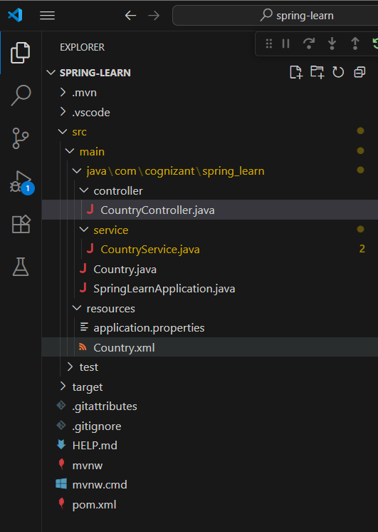

SpringLearnApplication.java

package com.cognizant.spring_learn;

import org.springframework.boot.SpringApplication;

import org.springframework.boot.autoconfigure.SpringBootApplication;

@SpringBootApplication

public class SpringLearnApplication {

    public static void main(String[] args) {

        SpringApplication.run(SpringLearnApplication.class, args);

    }

}

Country.java

package com.cognizant.spring_learn;

public class Country {

    private String country_code;

    private String country_name;

    public Country() {

    }

    public String getCode() {

        return country_code;

    }

    public void setCode(String code) {

        this.country_code = code;

    }

    public String getName() {

        return country_name;

    }

    public void setName(String name) {

        this.country_name = name;

    }

    @Override

    public String toString() {

        return "Country [code=" + country_code + ", name=" + country_name + "]";

    }

}

Country.xml

<?xml version="1.0" encoding="UTF-8"?>

<beans xmlns="http://www.springframework.org/schema/beans"

       xmlns:xsi="http://www.w3.org/2001/XMLSchema-instance"

       xsi:schemaLocation="http://www.springframework.org/schema/beans

       http://www.springframework.org/schema/beans/spring-beans.xsd">

    <bean id="country1" class="com.cognizant.spring_learn.Country">

        <property name="code" value="IN"/>

        <property name="name" value="India"/>

    </bean>

    <bean id="country2" class="com.cognizant.spring_learn.Country">

        <property name="code" value="US"/>

        <property name="name" value="United States"/>

    </bean>

    <bean id="country3" class="com.cognizant.spring_learn.Country">

        <property name="code" value="DE"/>

        <property name="name" value="Germany"/>

    </bean>

    <bean id="country4" class="com.cognizant.spring_learn.Country">

        <property name="code" value="JP"/>

        <property name="name" value="Japan"/>

    </bean>

    <bean id="countryList" class="java.util.ArrayList">

        <constructor-arg>

            <list>

                <ref bean="country1"/>

                <ref bean="country2"/>

                <ref bean="country3"/>

                <ref bean="country4"/>

            </list>

        </constructor-arg>

    </bean>

</beans>

CountryController.java

package com.cognizant.spring_learn.controller;

import org.springframework.beans.factory.annotation.Autowired;

import org.springframework.context.ApplicationContext;

import org.springframework.context.support.ClassPathXmlApplicationContext;

import org.springframework.web.bind.annotation.GetMapping;

import org.springframework.web.bind.annotation.PathVariable;

import org.springframework.web.bind.annotation.RestController;

import com.cognizant.spring_learn.Country;

import com.cognizant.spring_learn.service.CountryService;

@RestController

public class CountryController {

    ApplicationContext context = new ClassPathXmlApplicationContext("Country.xml");

    @GetMapping("/country")

    public Country getCountryIndia(){

            Country country = context.getBean("country", Country.class);

            return country;

        }

     @Autowired

    private CountryService countryService;

    @GetMapping("/countries/{code}")

    public Country getCountry(@PathVariable String code) {

        Country country = countryService.getCountry(code);

        return country;

    }

}

CountryService.java

package com.cognizant.spring_learn.service;

import org.slf4j.Logger;

import org.slf4j.LoggerFactory;

import org.springframework.stereotype.Service;

import org.springframework.context.ApplicationContext;

import org.springframework.context.support.ClassPathXmlApplicationContext;

import java.util.*;

import com.cognizant.spring_learn.Country;

@Service

public class CountryService {

    private static final Logger LOGGER = LoggerFactory.getLogger(CountryService.class);

    public Country getCountry(String code) {

        LOGGER.info("START: getCountry() in Service");

        ApplicationContext context = new ClassPathXmlApplicationContext("Country.xml");

        List<Country> countryList = (List<Country>) context.getBean("countryList");

        Country result = countryList.stream()

                .filter(c -> c.getCode().equalsIgnoreCase(code))

                .findFirst()

                .orElse(null);

        LOGGER.info("END: getCountry() in Service");

        return result;

    }

}

Output

